1. Add Database connection and take all required files

To add database double click on “Add Database Connection” provide all required connection information and connect to database either by [Right click > Connect] or by double click.

Take all required files from database.

[Kerala.SDE.IMD_Station], [ Kerala.SDE.Taluk] and [Kerala.sde.Station_SPI].

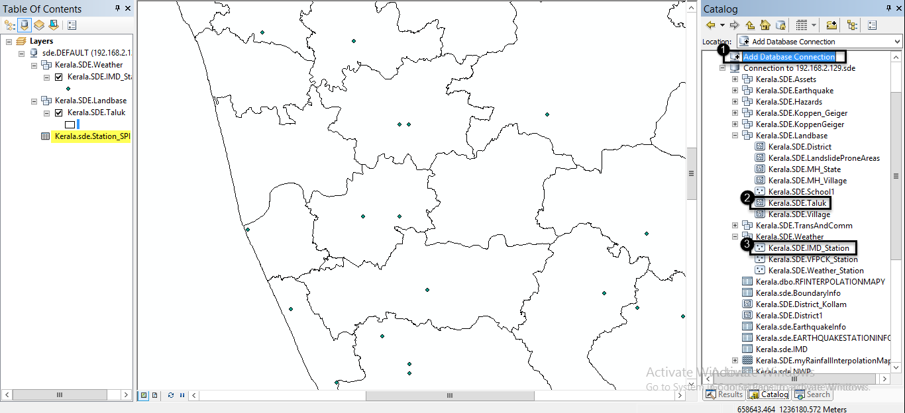

1. Join [Kerala.SDE.IMD_Station] and [Kerala.sde.Station_SPI].

To do so right click on [Kerala.SDE.IMD_Station] > Joins and Relates > Join.

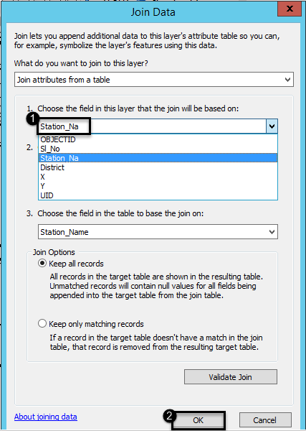

Select Perform join now without index > OK.

1. Run IDW Function.

